OUTPUT:
Q1 )
ADDING A NEW BOOK:
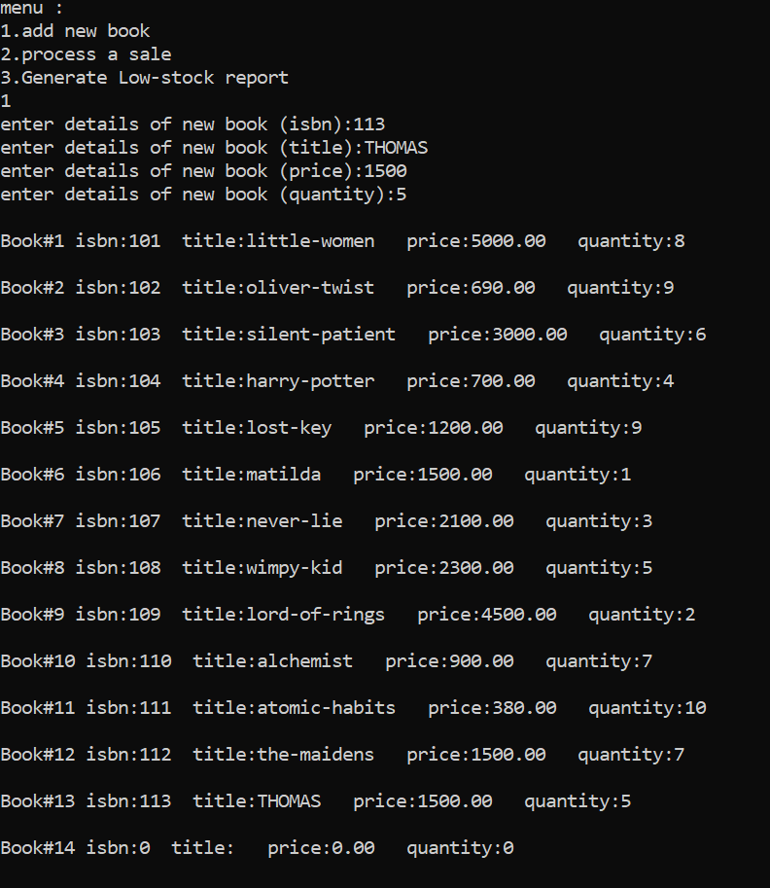

LOW STOCK REPORT:
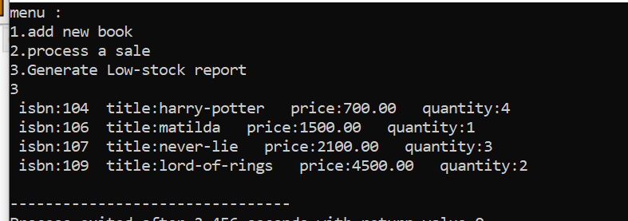
PROCESSING A SALE:
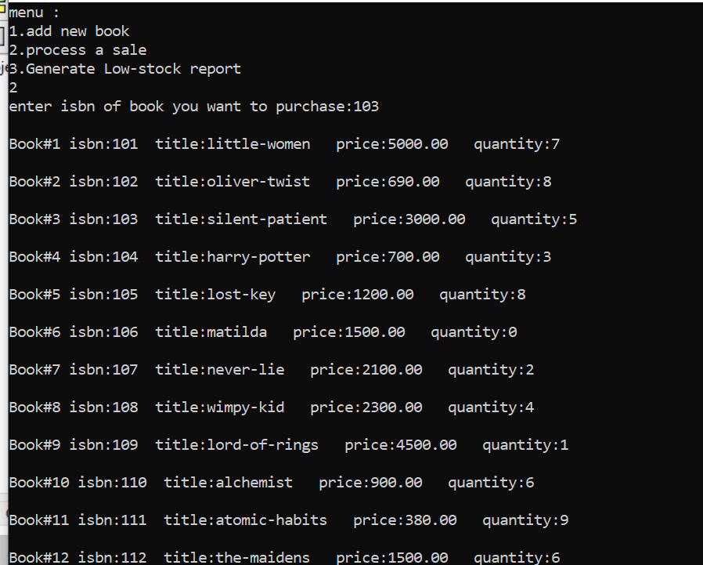

Q2)
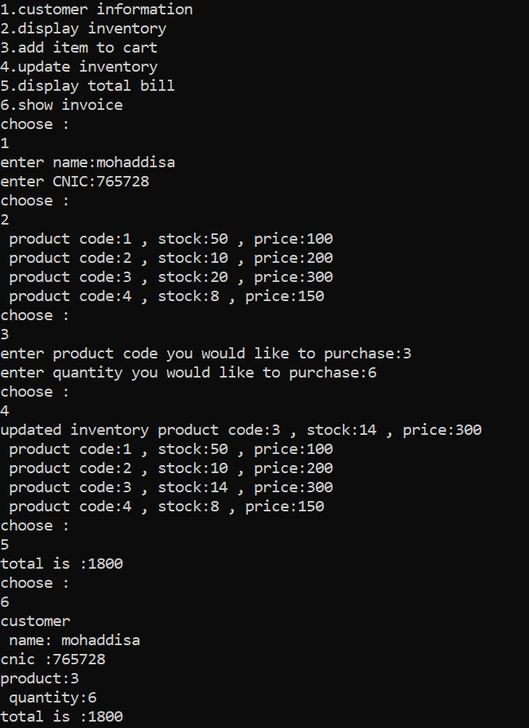

Q3)
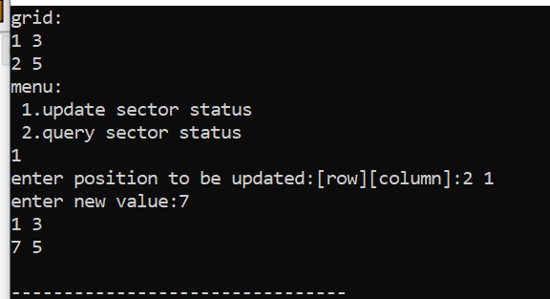
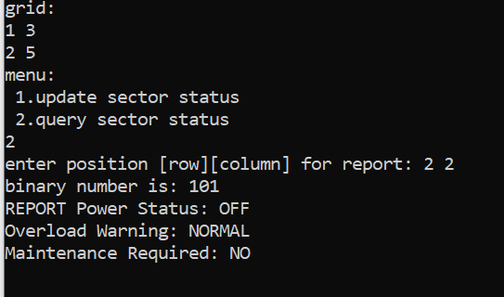

Q4)
Output:
enter maxsize:4

MENU
Enter your desired operation option:
1) PUSH: Insert element into stack
2) POP: Remove the top element
3) PEEK: Display the top element
4) DISPLAY: Show all elements
5) EXIT
1
enter number you would like to push:6

Element (6) added successfully!

MENU
Enter your desired operation option:
1) PUSH: Insert element into stack
2) POP: Remove the top element
3) PEEK: Display the top element
4) DISPLAY: Show all elements
5) EXIT
1
enter number you would like to push:5

Element (5) added successfully!

MENU
Enter your desired operation option:
1) PUSH: Insert element into stack
2) POP: Remove the top element
3) PEEK: Display the top element
4) DISPLAY: Show all elements
5) EXIT
3

Peek element is: 5

MENU
Enter your desired operation option:
1) PUSH: Insert element into stack
2) POP: Remove the top element
3) PEEK: Display the top element
4) DISPLAY: Show all elements
5) EXIT

